Phase 1: Study of Q1 and counting the codes that one of the padlocks supports

Main objectives and issues
For the teacher
- Observe what types of techniques are proposed for counting the number of codes on a padlock, when each group is responsible for calculating how many codes one of the padlocks supports.
- Introduce names and specific terminology to refer to the different techniques for counting the codes of each padlock.
For students
- Take responsibility for counting the total number of codes that a padlock supports.
- Prepare an answer R1 to Q1 for one of the padlocks, which have been assigned in Phase 1.
- Use various techniques to count the number of codes that a padlock supports and learn and compare them with those of other groups.
- Develop verbal, communicative and analytical skills to formulate, discuss, write and present different questions and answers in work groups and class groups.

Phase structure: main moments, timing and classroom dynamics

[1] Q1 group study, taking responsibility for one of the 60 minute locks
The teacher has assigned a different padlock to each work group (composed of 4-5 members) or, if there are more groups than padlocks, the assignment of groups to padlocks can be doubled.
The teacher reminds the groups that they have available Report-presentation 1 which, in working groups, they must prepare as a summary of the study they have carried out around the padlock for which they are responsible.
From here, the working groups begin to work, addressing Q1: How many codes does padlock XX support? in the case of the padlock that has been assigned to them. If deemed necessary, roles can be assigned within the group to facilitate distribution and responsibility in the study of Q1.
[2] Preparation of R1 30 minutes
The working groups prepare their answers R1 . The presentation included in Report-presentation 1 can be used directly or other alternative means: on blackboards, cardboard, or whatever is considered most appropriate. The teacher presents the questions included in Report-presentation 1 that aim to standardize the presentation that the different groups will make on each of the padlocks:
- Padlock characteristics: What are the characteristics of the padlocks you are studying?
- Simulation of possible codes: How to generate the list (even if it is partial) of possible codes that the padlock supports? What is the total number of codes that your padlock supports?
- Justification of how the number of codes was found: What counting strategies or techniques were used? How did we ensure that we did not overcount or undercount codes?
- Other questions about the padlock: It is also proposed to add the following extra questions to validate good justification and discussion between the groups:
About the time to open the padlock: If we have to open the padlock by trying all the codes, how long (minimum and maximum) do you estimate it would take to open the padlock?
About introducing variations in the padlock: If we have the same padlock with one more box, how would we find the total number of codes it supports? And if we have one more element per box? What would happen then?
[3] Sharing of responses prepared by each group 40-60 minutes
The teacher organizes the sharing where each working group presents their R1s through the presentation Report Presentation 1 that they have prepared and with the digital or analog support that they deem appropriate.
This sharing can be organized, for example, padlocks by padlock , from type 1 to 6 and, in the event that there are two groups working with the same padlock, it is necessary to compare the answers they have given to Q1 (included in the Presentation Report 1 ).
The teacher is responsible for, as the working groups explain, making a common table to record, for each padlock:
- Total codes supported by the padlock
- Estimate the minimum and maximum time it would take to open the padlock
See example Image 1 , below this Guide.
teacher must collect the Presentation 1 Report to, in the next phase, comment by updating the Guide Presentation on various aspects of the activity carried out, such as: types of techniques used to do the counting, terminology used and agreements on this, new issues that have arisen in this group work, among other aspects that are considered important.

Resources and materials needed/available
For teachers
Teacher's guide presentation . See slides dedicated to PHASE 1 .
You can use a padlet ( see example in Image 2 below) to centralize the different presentations of the groups, or use a task on Google. Classroom .
For students
padlocks , 6 in total , plus a description of the characteristics of each padlock. A different padlock is given to each group. If there are more than 6 groups, the assignment to the same padlock is doubled, especially for those that are more difficult to study.
Report -Presentation 1 with the structure previously commented: (a) Characteristics of the padlock; (b) Simulation of possible codes, (c) Justification of how the number of codes was found; (d) Other questions about the padlock.

Comments relevant to the management of Phase 1
Some padlocks are more difficult than others, so the sharing can also be planned taking this aspect into account. Remember that in the Introductory Teaching Guide you have available a Table with the described characteristics of each padlock.
Resisting...
Avoid emphasizing some of the most “well-known” techniques or strategies, such as combinatorics formulas, as if they were the most “valid.” They are often the most difficult to justify and it will be very valuable to include a variety of techniques: tree diagrams, unordered or ordered lists, etc.
Do not prevent them from searching for information on the topic, but emphasize the importance of finding out if the information found (for example: combinatorics formulas) fits and how it fits or corresponds to the case of the padlock they are studying.

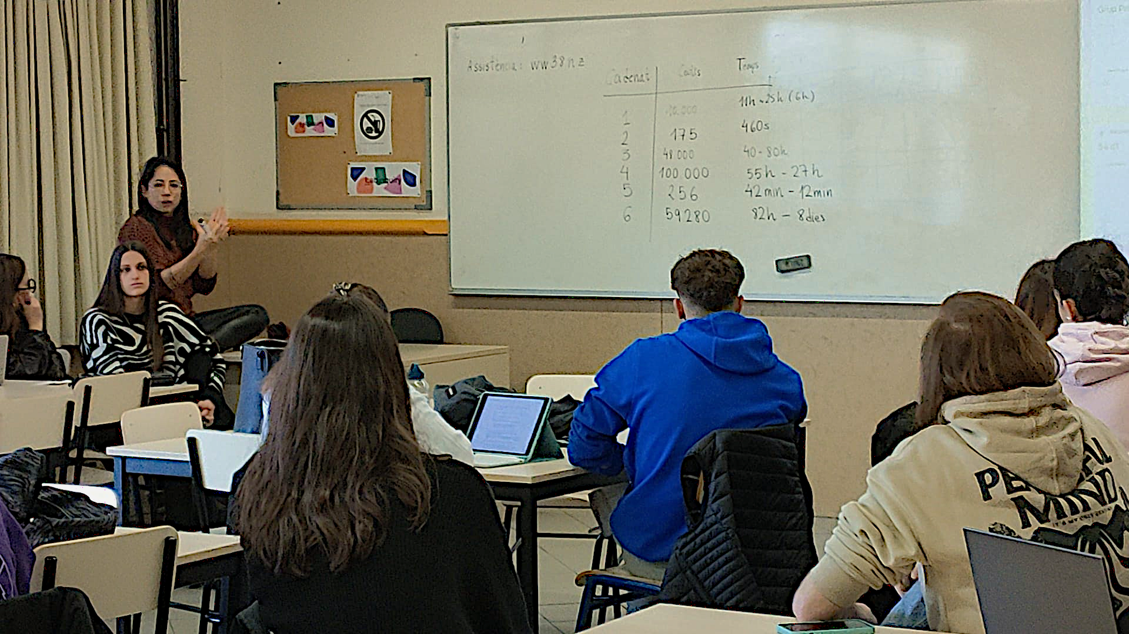

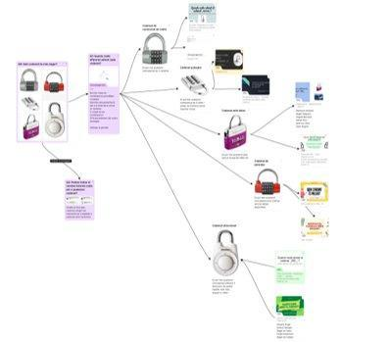
Imatge SEQ Ilustración \* ARABIC 1. Fotografia sobre la posada en comú amb taula comuna amb Nbr. Cadenat, Nbr. de Codis i Temps màxim
Imatge 2. Imatge padlet creat per a compartir les primeres presentacions dels responsables de cada cadenat

